**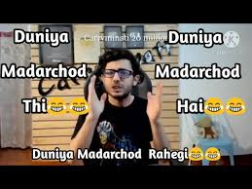  
Duniya** madarchod thi madarchod hai aur madarchod rahegi `